**Good News Nursing Center’s nutrition plan**

Good News Nursing Center is going to create a nutrition plan for pregnant clients. The Medical Care Department decided to provide a combination of two prenatal vitamin shakes to help maintain pregnant clients’ nutrition. For the first vitamin powder (powder A), one scoop weighs 37 grams and contains 120 calories and 5 grams of fat. For the second vitamin powder (powder B) weighs 65 grams and contains 160 calories and 10 grams of fat. However, gaining too much weight in pregnancy can have an adverse effect on a baby by increasing his or her lifelong risk of obesity, heart disease, and diabetes. Thus, a pregnant woman can only have no more than 450 calories and 25 grams of fat in her daily vitamin shake. In order to maintain nutrition for baby, a pregnant woman requires at least 120 grams of vitamin powder per day. There is a “Taste Score” based on the survey of all the previous clients’ preference who have tried these two powders, where 0 is the lowest, and 100 is the highest. Form the survey, Powder A got a “Taste Score” of 95 and powder B got 85. Use Solver to find the daily nutrition plan that stays within the constraints and maximizes the total taste score of the vitamin shakes.

**Discussion: -**

In this problem, there are two options (Powder A and Powder B) to take daily. Each serving item has specific parameters (weights, calories, fat, taste score) which are our inputs. Let’s discuss about one parameter ‘weights’, which will help us in finding our decision variable. From the nutrition plan, a pregnant woman must take 120 grams of vitamin powder in a day. Powder A and Powder B contains 37 and 65 grams respectively. If we can decide the number of serving items, we can calculate the total intake of vitamin powder, which will help us in calculating the taste score. With the available inputs we can calculate only the taste score of only one serving. If we have the number of servings that a pregnant woman is getting in a day, we can calculate the total taste score. So, our decision variable should be the number of servings. Our objective is to maximize the taste score value by deciding the number of serving items. A pregnant woman should take the serving in such a way that her intake calories, grams and fat are in control, which will be constraints in this problem.

**Mathematical Model: -**

*Parameters (Inputs):*

$$i ϵ 1,2, \left( Index for items powder A ,powder B\right)$$

$W_{i} :Weights of item i$

$$C_{i} :Calories in item i$$

$$F_{i} :Fat in item i$$

$$T_{i} :Taste Score to each gram of item i$$

$$W :Per day limitations of weight$$

$$C :Per day limitations of Calories$$

$$F :Per day limitations of fat$$

*Decision Variables:*

$$x_{i} :Number of servings of item i$$

*Objective:*

$$Maximize Total Taste Score=\sum_{i=1}^{2}{{(x}_{i}*W_{i}*T_{i})}$$

*Constraints:*

$$x_{i}≥0 \left(1\right)Non Negative constraint$$

$$\sum_{i=1}^{2}{{(x}_{i}*W_{i})}≥W \left(2\right)Per day limitations of weight constraint$$

$$\sum_{i=1}^{2}{{(x}_{i}*C_{i})}≤ C (3)Per day limitations of Calories constraint$$

$$\sum_{i=1}^{2}{{(x}_{i}*F_{i})}≤F (4)Per day limitations of fat constraint$$

*Excel Implementation:*

Please find the attached spreadsheet for solution.

[Ex6[Maggie Stewart].xlsx](Ex6%5bMaggie%20Stewart%5d.xlsx)

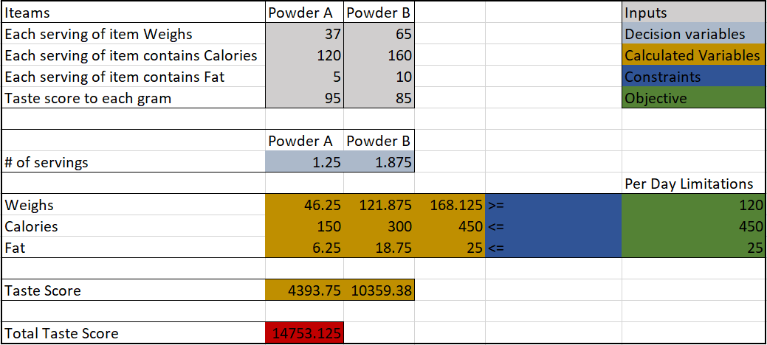

As per the optimization model a pregnant woman can take 1.25 serving of powder A and 1.875 servings of powder B. As our objective is to maximize the Total taste score, solver suggests powder B over powder A as it has higher per gram taste score.

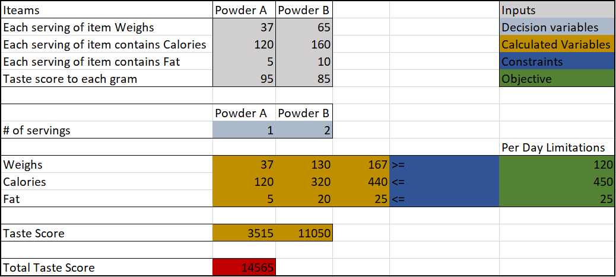

If we put integer constraint for our decision variables, solution would be as given in screenshot 2. As per the optimization model a pregnant woman can take 1 serving of powder A and 2 servings of powder B. To meet the Calories and Fat constraints, solver didn’t pick the 3rd unit of powder B.